Question – 1 Write a program to find the Nth term of the Fibonnaci series.

Ans.

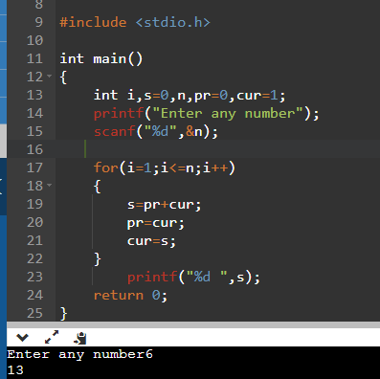

Question – 2 Write a program to print first N terms of Fibonacci series.

Ans.

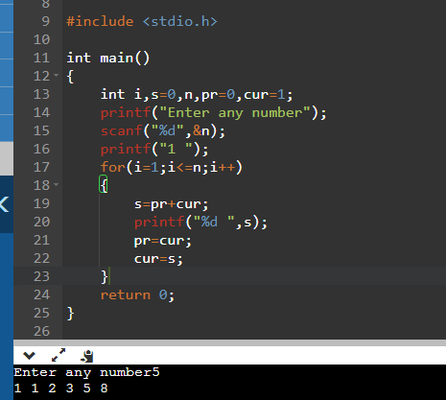

Question – 3 Write a program to check whether a given number is there in the Fibonacci series or not.

Ans.

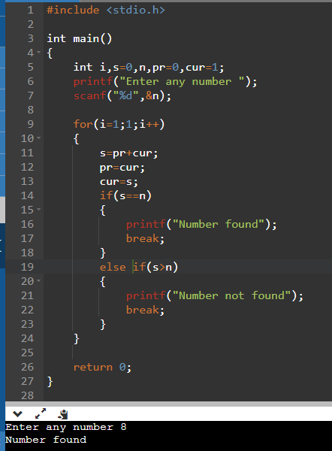

Question – 4 Write a program to calculate HCF of two numbers.

Ans.

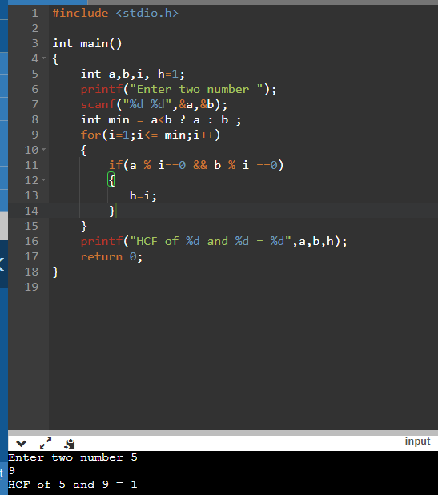

Question – 5 Write a program to check whether two given numbers are co-prime numbers or not.

Ans.

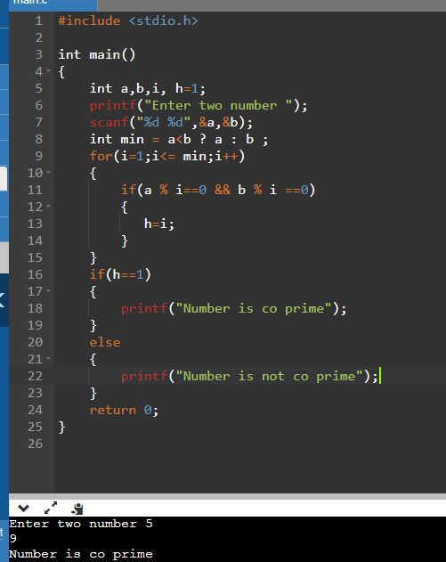

Question – 6 Write a program to print all Prime numbers under 100.

Ans.

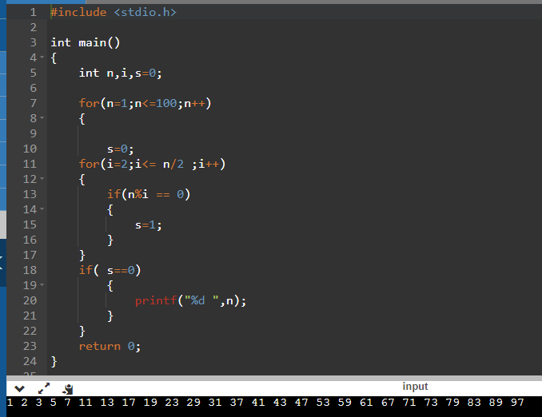

Question – 7 Write a program to print all Prime numbers between two given numbers.

Ans.

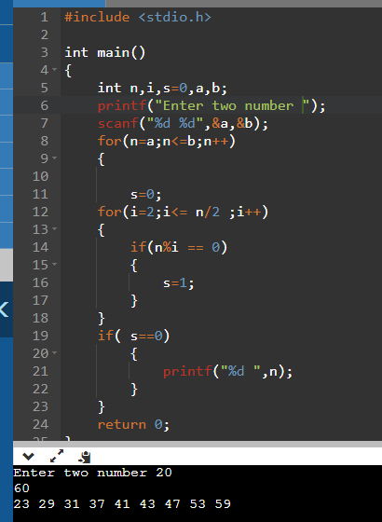

Question – 8 Write a program to find next Prime number of a given number.

Ans.

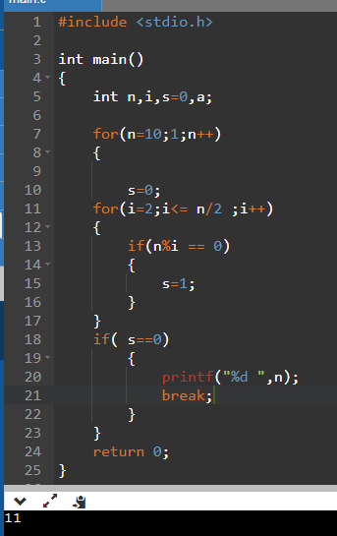

Question – 9 Write a program to check whether a given number is an Armstrong number or not.

Ans.

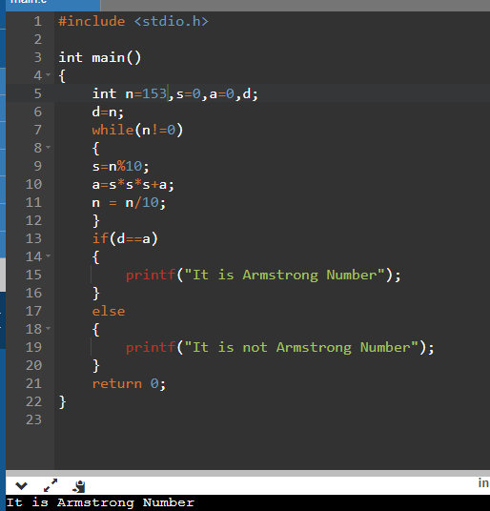

Question – 10 Write a program to print all Armstrong numbers under 1000.

Ans.

